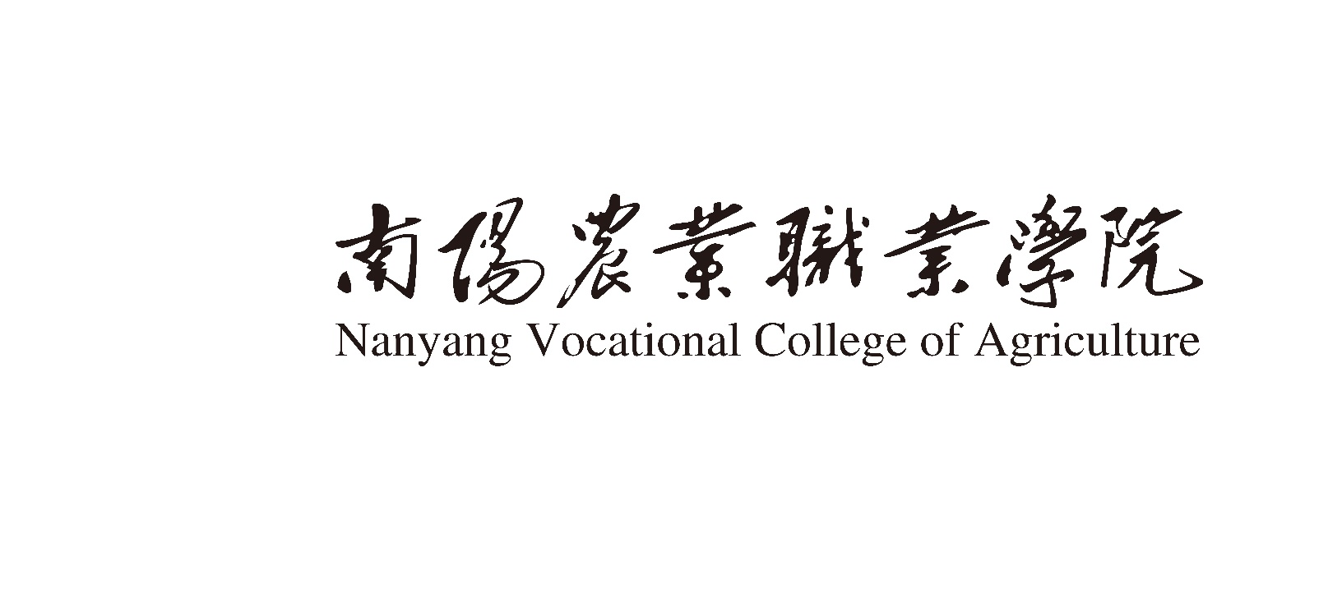

学 期 授 课 计 划

202　～202　　学年　　第　　　学期

|  |  |
| --- | --- |
| **课程名称：** |  |
| **授课班级：** |  |
| **任课教师：** |  |
| **专业学制：** |  |
| **编制人：** |  |
| **编制日期：** |  |

南阳农业职业学院教务处编制

## 编 制 说 明

|  |  |  |  |  |  |  |  |  |  |  |
| --- | --- | --- | --- | --- | --- | --- | --- | --- | --- | --- |
| **人才培养方案规定学时** | **总学时** | | **已完成学时** | | | | **本学期学时** | | | |
|  | |  | | | |  | | | |
| **本学期**  **学时分配** | **理论教学** | | | **实践教学** | | | | | **其他** | |
| **课堂**  **讲授** | **一体化**  **教学** | **多媒体** | **实验** | | **实习**  **实训** | | | **考核** | **机动** |
|  |  |  |  | |  | | |  |  |
| **使用教材** | **名称** | | | **编者** | | **版本** | | | **出版社** | |
|  | | |  | |  | | |  | |
| **课程标准名称** | ××专业《××》课程标准 | | | | | | | | | |
| **课程目标** |  | | | | | | | | | |
| **提高教学质量的措施与方法** |  | | | | | | | | | |
| **考核成绩测评方案** | 作业占 %，测验占 %，期末占 %。 | | | | | | | | | |
| **教研室审核意见** |  | | | | **日期** | | |  | | |
| **系（部）主 任审核意见** |  | | | | **日期** | | |  | | |

**备注：在正式上课一周内交教务处存档，系（部）存档。**

**教 学 时 数 分 配 表**

|  |  |  |  |  |
| --- | --- | --- | --- | --- |
| **章　次** | **章 节 名 称** | **总时数** | **其中（学时）** | |
| **理论讲授** | **实验/实践** |
| 第一章 |  |  |  |  |
| 第二章 |  |  |  |  |
| 第三章 |  |  |  |  |
| 第四章 |  |  |  |  |
| 第五章 |  |  |  |  |
| 第六章 |  |  |  |  |
| 第七章 |  |  |  |  |
| 第八章 |  |  |  |  |
| 第九章 |  |  |  |  |
|  |  |  |  |  |
|  |  |  |  |  |
|  |  |  |  |  |
|  | 合计 |  |  |  |

**教 学 进 程 表**

|  |  |  |  |  |
| --- | --- | --- | --- | --- |
| **顺序** | **授课单元摘要** | **时数** | **教学措施**  **能力目标** | **课外作业** |
| 1 |  |  |  |  |
| 2 |  |  |  |  |
| 3 |  |  |  |  |
| 4 |  |  |  |  |
| 5 |  |  |  |  |
| 6 |  |  |  |  |
| 7 |  |  |  |  |
| 8 |  |  |  |  |
| 9 |  |  |  |  |
| 10 |  |  |  |  |
| 11 |  |  |  |  |
| 12 |  |  |  |  |
| 13 |  |  |  |  |
| 14 |  |  |  |  |
| 15 |  |  |  |  |